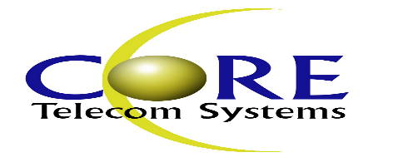

To whom it may concern:

This letter is to confirm that E-Logic is authorized to purchase Eltek/Delta products from Core Telecom Systems who is an authorized reseller for Eltek / Delta Electronics (USA) Inc.

Thanks,

Rene’ Ehlenfeldt – Regional Sales Manager

511 South 2nd Street

Shenandoah, VA 22849

Cell: 314-456-2812

